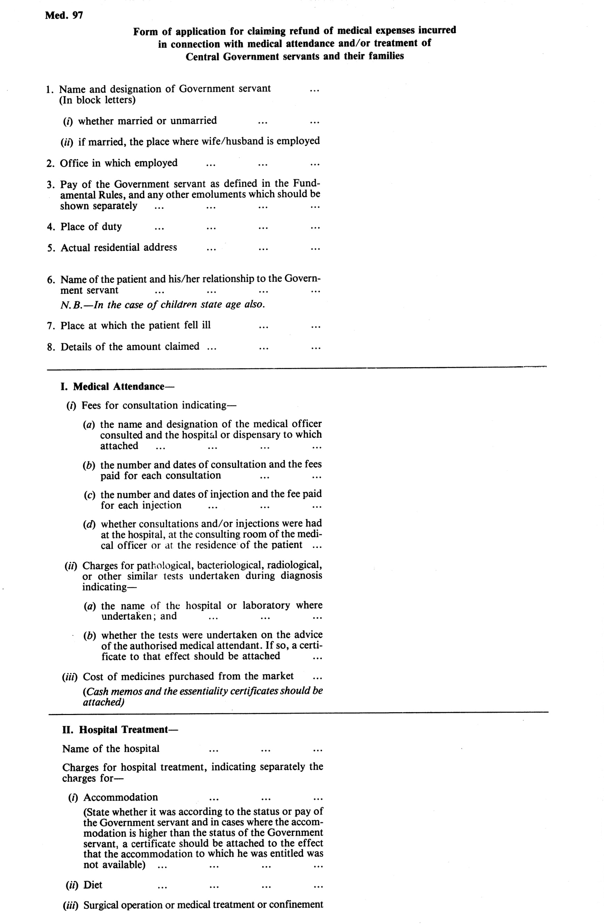

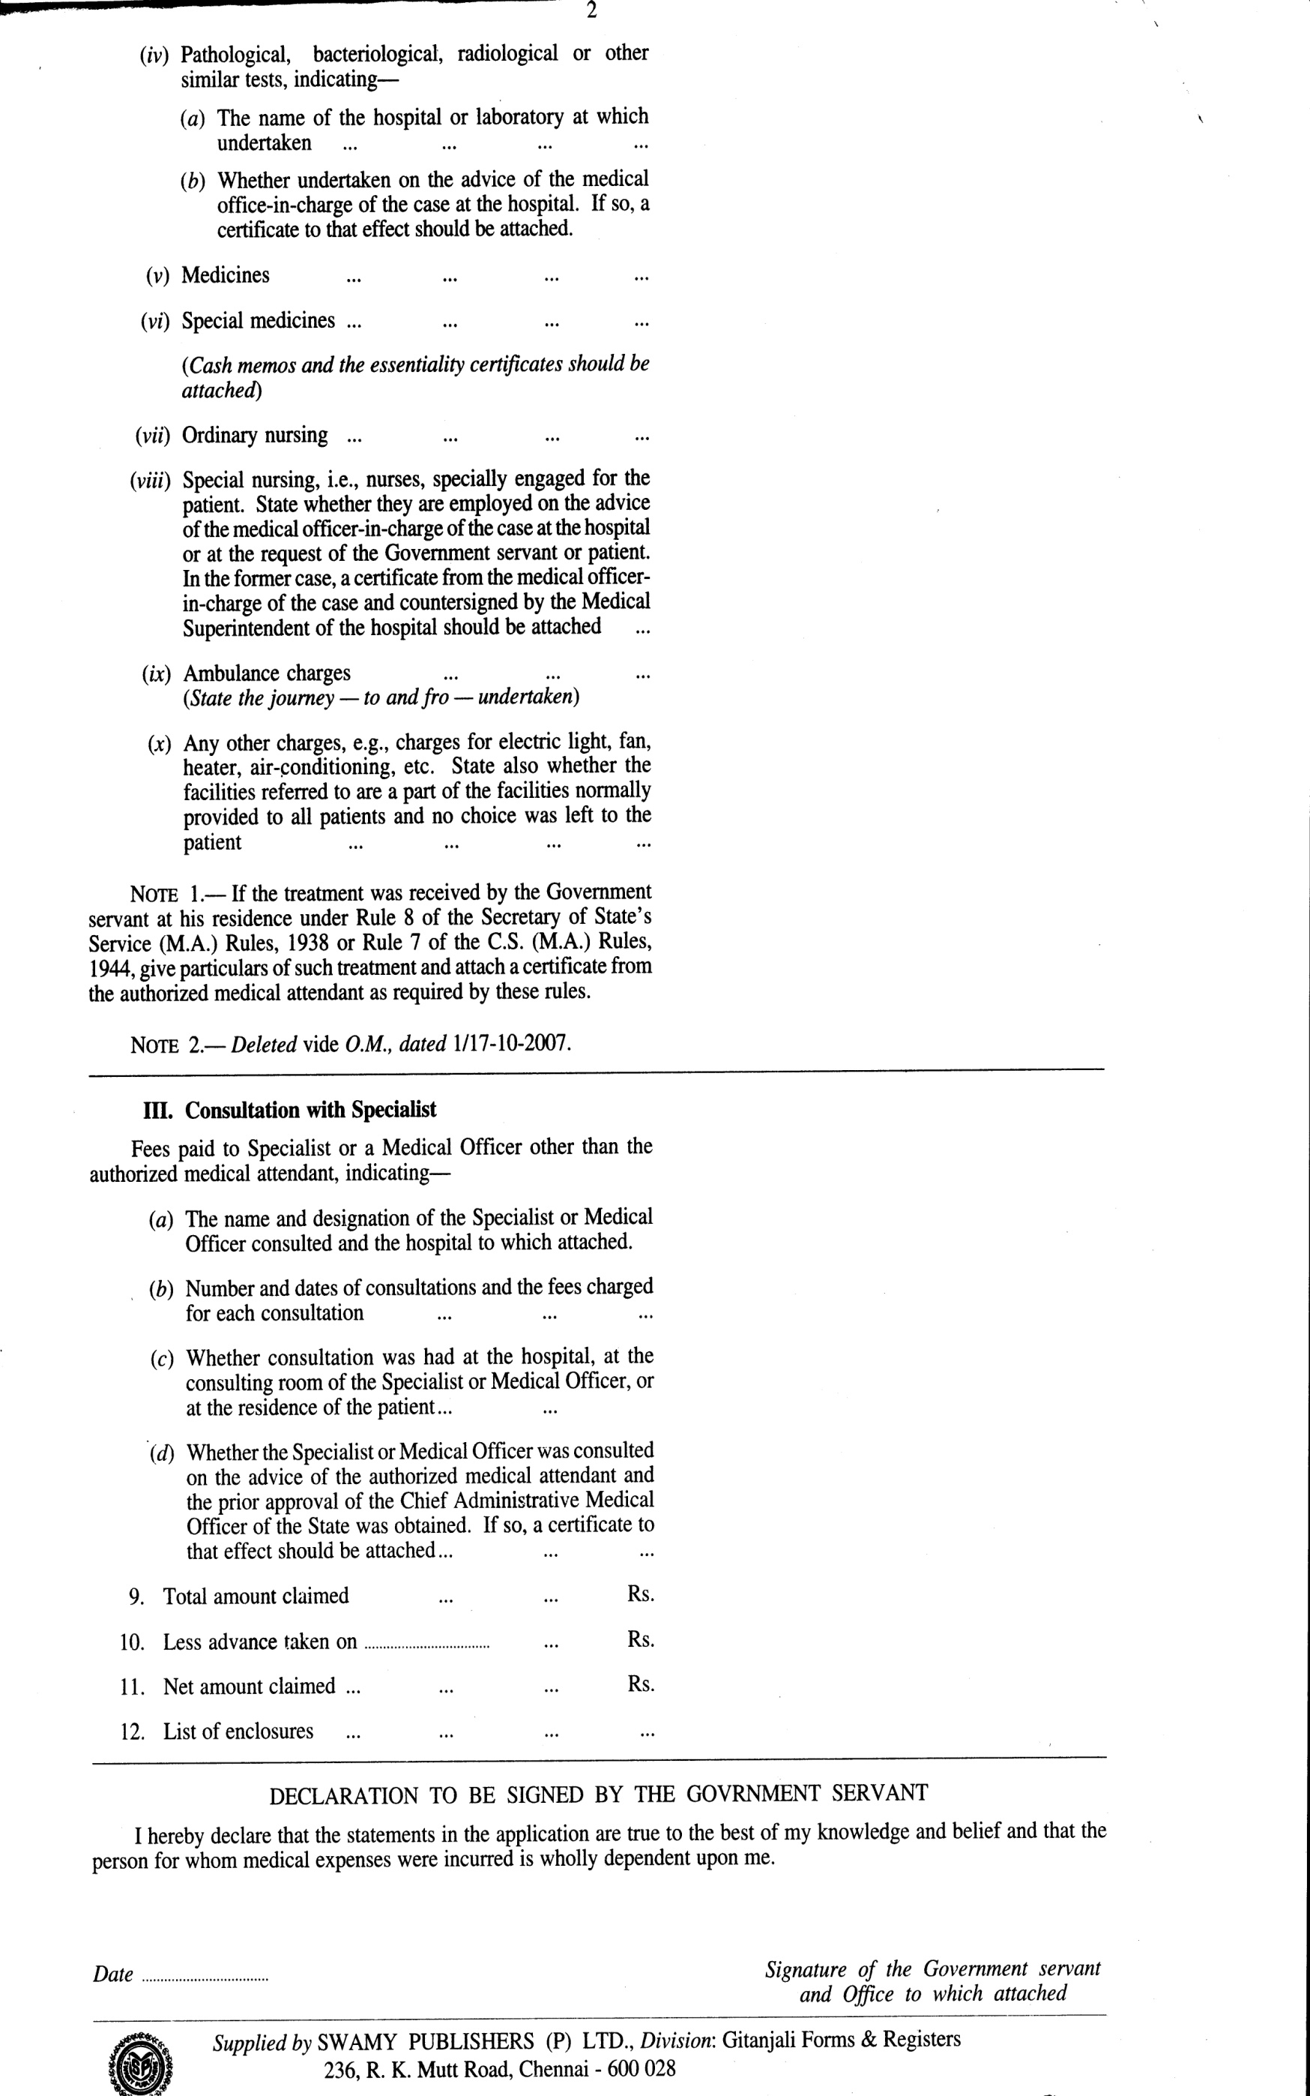

Certificate granted to Mrs/Mr/ Miss ....................……………………………………………………………
wife/son/daughter of Mr…………………………………………………………………………. employee College of Agricultural Engineering and Post Harvest Technology, Ranipool, Gangtok
CERTIFICATE ‘A’
I, Dr. ……………………………………………………………………………………………………….. hereby certify –
(a) | that I charged and received ` ……………………….. for consultations on ……………………..  (dates to be given) at my consulting room/at the residence of the patient;
(b) | that I charged and received `…………………….. for administering intra venous /intramuscular /subcutaneous injections on ……………………………………………………….. at my consulting room/the residence of the patient(date to be given)
(c) | that the injection administered were not/were for immunizing or prophylactic purposes;
(d) | that the patient has been under treatment at …………………………hospital/my consulting room and that the under mentioned medicines prescribed by me in this connection were essential for the recovery/prevention of serious deterioration in the condition of the patient. The medicine are not stocked in the …………………………………..(name of hospital) for supply to private patients and do not include proprietary preparations for which cheaper substances of equal therapeutic value are available nor preparations which are primarily foods, toilets or disinfectants.
Sl No | Name of medicines | Price
 |  | Rs. | P

(i) | that the patient is/was suffering from …………………………………………… and is/was under my treatment from ………………………………… to ………………………………………………..
(j) | that the patient is/was not given pre-natal or post natal treatment;
(k) | that the X-ray, laboratory test etc. for which an expenditure of ` …………….. was incurred was necessary and were undertaken on my advice at ……………………………….. (name of the hospital or laboratory);
(l) | that I referred that patient to Dr. ……………………………………… for Specialist consultation and that the necessary approval of the …………………………………(name of the Chief Administrative Officer of the State) as required under the rules was obtained;
(m) | that the patient did not require/required hospitalization.
Dated: …../…../……… Signature of AMA/Designation of the
Medical Officer and hospital
dispensary to which attached
N.B- Certificate not applicable should be struck off. Certificate (e) is compulsory and must be filled in by the Medical Officer in all cases.

