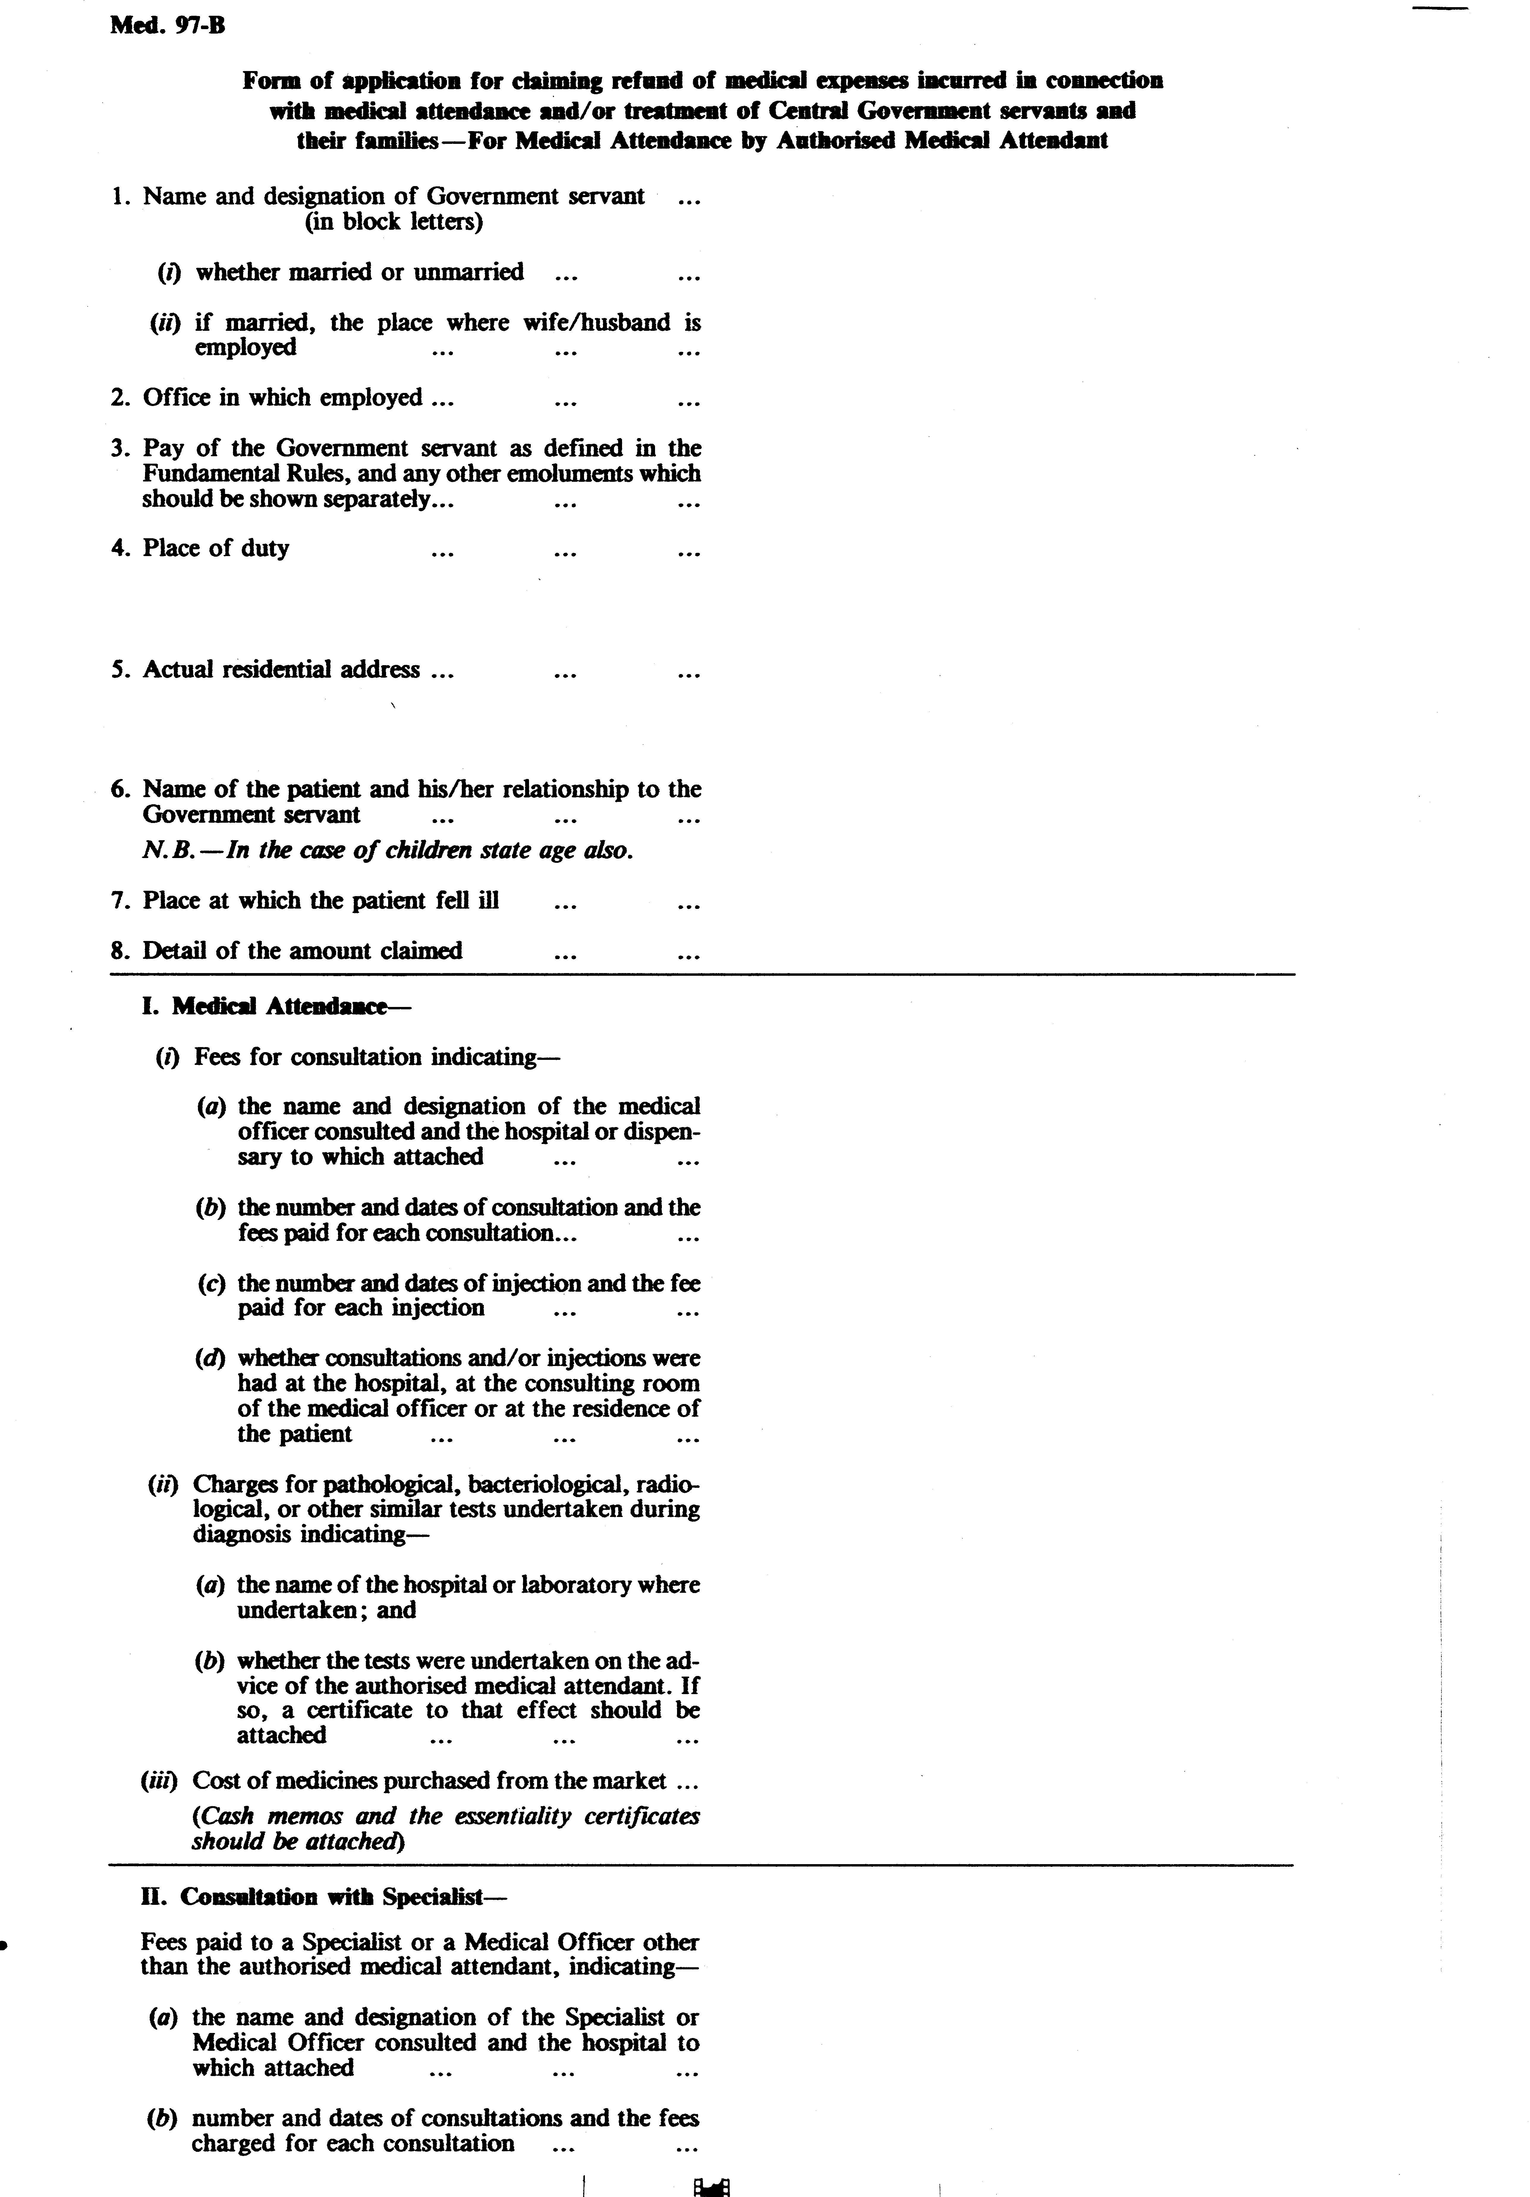
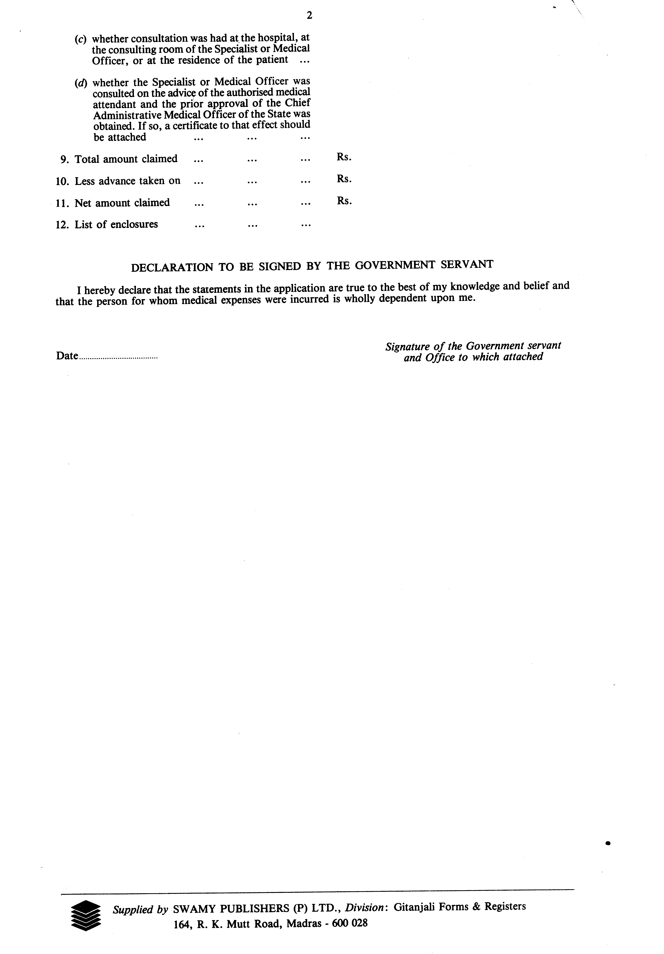

CERTIFICATE ‘B’
(To be completed in the case of patient who are admitted to hospital for treatment)
Certificate granted to Mr/Mrs/Miss ……………………………………………………………………..
Wife/son/daughter of Mr. ……………………………………………………………………... employed in
The College of Agriclutural Engineering & Post Harvest Technology, Ranipool, Gangtok.
PART – A
I, Dr. ………………………………………………………………………………….... hereby certify-
(a) | that tha patient was admitted to hospital on the advice of …………………………………………  (name of the Medical Officer) on my advice;
(b) | that the patient has been under treatment at …………………………………………………………..  and that the under mentioned medicines prescribed by me in this connection were essential for the recovery/prevention of serious determination in the condition of the patient. The medicines are not stocked in the …………………………………………………………………………………………  (name of the hospital) for supply to private patients and do not include proprietary preparations for which cheaper substances of equal therapeutic valye are available not preparations which are primarily foods, toilets or disinfectants;
 | Name of medicines - ……………………………………… - ……………………………………… - ……………………………………… - ……………………………………… Price …………………………………. …………………………………. …………………………………. …………………………………
(c ) | that the injection administered were/were not for immunizing or prophylactic purposes;
(d) | that the patient is/was suffering from …………………………………………………………. and  is /was under treatment from …………………………………… to …………………………;
(e) | that the X-ray, laboratory tests, etc for which an expenditure of ` ………………………………….  was incurred were necessary and were undertaken on my advice at ………………………...  (name of hospital or laboratory);
(f) | that I called on Dr. ………………………………………………………….. for special consultation  and that the necessary approval of the …………………………………………. (Name of the Chief  Administrative Medical Officer of the State) as required under the rules, was obtained.
Signature and Designation of the
Medical Officer in charge of the
Case at the hospital
PART – B
I certify that the patient has been under treatment at the ……………………………………………
Hospital and that the service of the special nurses for which an expenditure of ` …………………..
was incurred, vide bills and receipts attached, were essential for the recovery/prevention of serious deterioration in the condition of the patient.

Signature of the Medical Officer
In charge of the case at the Hospital
COUNTERSIGNED

Medical Superintendent
………………………… hospital

I certify that the patient has been under treatment at the ……………………………………………..
Hospiral and that the facilities provided were the minimum which were essential for the patient’s treatment.

Medical Superintendent
Place …………………… ……………………….. hospital
NOTE – Certificates not applicable should off. Certificate (d) is compulsory and must be filled in
by the Medical Officer in all cases.

